Exception Handling in C#

Types of errors in C#
When we write and execute our code in the .NET framework then there is a possibility of two types of error occurrences they are
- Compilation errors
- Runtime errors
Compilation Error in C#
An error that occurs in a program at the time of compilation is known as compilation error (compile-time error). These errors occur due to the syntactical mistakes under the program. That means these errors occur by typing the wrong syntax like missing double quotes and terminators, typing wrong spelling for keywords, assigning wrong data to a variable, trying to create an object for abstract class and interface, etc.
So in the simple word we can say that this type of error occurs due to the poor understanding of the programming language. These errors can be identified by the programmer and can be rectified before the execution of the program only. So these errors do not cause any harm to the program execution.
Runtime Error in C#
The errors which occurred at the time of program execution are called as the runtime error. These errors occurred when we entering wrong data into a variable, trying to open a file for which there is no permission, trying to connect to the database with wrong user id and password, the wrong implementation of logic, missing of required resources, etc.
Runtime errors are dangerous because whenever they occur in the program, the program terminates abnormally on the same line where the error gets occurred without executing the next line of code.
What is an Exception in C#?
A runtime error is known as an exception. The exception will cause the abnormal termination of the program execution. So these errors (exceptions) are very dangerous because whenever the exception occurs in the programs, the program gets terminated abnormally on the same line where the error gets occurred without executing the next line of code.
Who is responsible for abnormal termination of the program whenever runtime errors occur in the program?
Objects of exception classes are responsible for abnormal termination of the program whenever runtime errors (exceptions) occur. These exception classes are predefined under BCL (Base Class Libraries) where a separate class is provided for each and every different type of exception like
- IndexOutOfRangeException int[]arr=new int[10];
- FormatException
- NullReferenceException
- DivideByZeroException 10/0
- FileNotFoundException
- SQLException,
- OverFlowException, etc.
- Exception class
Each exception class provides a specific exception error message. All the exception classes are responsible for abnormal termination of the program as well as after abnormal termination of the program they will be displaying an error message which specifies the reason for abnormal termination i.e. they provide an error message specific to that error.
whenever a runtime error (exception) occurs in a program, first the exception manager under the CLR (Common Language Runtime) identifies the type of error that occur in the program, then creates an object of the exception class related to that error and throws that object which will immediately terminate the program abnormally on the line where error got occur and display the error message related to that class.
What happens if an exception is raised in the program?
Program execution terminated abnormally. That means the statements placed after exception causing statement are not executed but the statements placed before that exception causing statement are executed by CLR.
What CLR does when an exception occurred in the program?
It creates the exception class object that is associated with that logical mistake and terminates the current method execution by throwing that exception object by using the “throw” keyword.
So we can say an exception is an event that occurs during the execution of a program that disrupts the normal flow of instruction execution. Let’s understand this with an example.
Example1: The below example shows program execution without exception
namespace ExceptionHandlingDemo
{
class Program
{
static void Main(string[] args)
{
int a = 20;
int b = 10;
int c;
Console.WriteLine("A VALUE = " + a);
Console.WriteLine("B VALUE = " + b);
c = a / b;
Console.WriteLine("C VALUE = " + c);
Console.ReadKey();
}
}
}
Output:
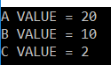
Exception handling in C# using the Try Catch implementation
To implement the try-catch implementation .NET framework provides three keywords
- Try
- Catch
- finally
Try:

complaint@janshikayat.in
The try keyword establishes a block in which we need to write the exception causing and its related statements. That means exception causing statements must be placed in the try block so that we can handle and catch that exception for stopping abnormal termination and to display end-user understandable messages.
Catch:
The catch block is used to catch the exception that is thrown from its corresponding try block. It has the logic to take necessary actions on that caught exception.
Catch block syntax is look like a constructor. It does not take accessibility modifier, normal modifier, return type. It takes the only single parameter of type Exception.
Inside catch block, we can write any statement which is legal in .NET including raising an exception.
Finally:
The keyword finally establishes a block that definitely executes statements placed in it.
Statements that are placed in finally block are always executed irrespective of the way the control is coming out from the try block either by completing normally or throwing an exception by catching or not catching.

class Program
{
int c = 0;

public void div(int n1, int n2)
{
try
{
c = n1 / n2;

}
catch (DivideByZeroException e)
{
Console.WriteLine("exception caught {0}", e);

}
finally
{
Console.WriteLine("result is {0} " + c);
}

}

static void Main(string[] args)
{
Program p = new Program();
p.div(20, 0);

}
}
}

Syntax to use Exception Handling:
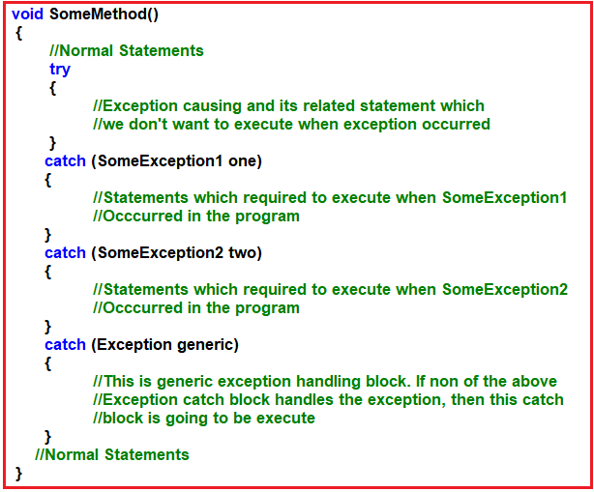
Multiple Catch Block

class Program
{
int c = 0;

public void div()
{
int[] arr = { 10, 0, 20 };
try
{
for (int i=0;i<arr.Length;i++)
{
Console.WriteLine(arr[i] / arr[i + 1]);

}
}catch(IndexOutOfRangeException e)
{

Console.WriteLine("an exception occured" + e.Message);
}
catch (DivideByZeroException e)
{
Console.WriteLine("an exception occured" + e.Message);

}
catch (ArgumentOutOfRangeException e)
{
Console.WriteLine("an exception occured" + e.Message);

}

finally
{
for( int i=0;i<arr.Length;i++)
{
Console.WriteLine("{0}", arr[i]);
}
}

}

static void Main(string[] args)
{
Program p = new Program();
p.div();

}
}
}

Once we use the try and catch blocks in our code the execution takes place as following
- If all the statements under try block are executed successfully, from the last statement of the try block, the control directly jumps to the first statement that is present after the catch block (after all catch blocks) without executing catch block (it means there is no runtime error in the code at all ).
- Then if any of the statements in the try block causes an error, from that statement without executing any other statements in the try block, the control directly jumps to the catch blocks searching for a catch block to handle that exception.
- If a proper catch block is available that handles the exception, then the abnormal termination stops there, executes the code under the catch block and from there again it jumps to the first statement after all the catch blocks.
- Then if a matching catch is not available abnormal termination occurs again.

In C#, the exceptions are divided into two types such as
- System exception
- Application exception
What are System Exceptions in C#?
An exception that is raised implicitly under a program by the exception manager because of some logical mistakes (some predefined conditions) is known as system exception. For example:
- DivideByZeroException
- IndexOutOfRangeException
- FormatExceptionetc
An exception that is raised explicitly under a program based on our own condition (i.e. user-defined condition) is known as the application exception.
What are Application Exceptions in C#?
An exception that is raised explicitly under a program based on our own condition (i.e. user-defined condition) is known as an application exception. As a programmer, we can raise application exception at any given point of time. To raise an application exception we need to adopt the following process
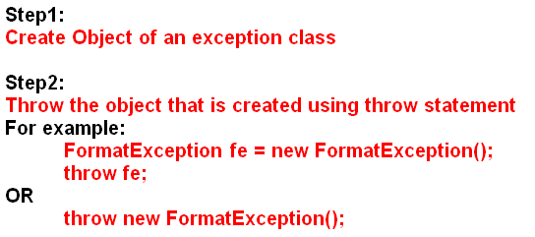
While creating and throwing an object of Exception class we should not use system exception classes like DivideByZeroException, FormatException, etc.
Why do we need to create custom exceptions in C#?
If none of the already existing .NET exception classes serve our purpose then we need to go for custom exceptions in C#.
class TestTemperature
{
static void Main(string[] args)
{
Temp t = new Temp();
try
{
t.showTemp();
}
catch (Temperature e)
{
Console.WriteLine(e.Message);
}
Console.ReadKey();
}
}
}
public class Temperature : Exception
{
public Temperature(string message) : base(message)
{
}
}
public class Temp
{
int temper = 32;

public void showTemp()
{

if (temper == 0)
{
throw (new Temperature("Zero Temperature found"));
}
else
{
Console.WriteLine("Temperature: {0}", temper);
}
}
}

public class ouOfStock : Exception
{
public ouOfStock(string messsage) : base(messsage)
{

}
}
class Program
{
static void Main(string[] args)
{

int acceptorder;
Console.WriteLine("welcome to shoppint site");
acceptorder = Convert.ToInt32(Console.ReadLine());
try
{
if (acceptorder == 10 || acceptorder < 10)
{
Console.WriteLine("congrats you have bought {0}", acceptorder);

}
else
{

throw new ouOfStock("out vof stock");

}
}
catch (ouOfStock ec)
{
Console.WriteLine(ec.Message);
}

}
}
}

Inner Exception Example in C#:
Let us say we have an exception inside a try block which is throwing DivideByZeroException and the catch block catches that exception and then tries to write that exception to a file. However, if the file path is not found, then the catch block is also going to throw FileNotFoundException.
Let’s say the outside try block catches this FileNotFoundException exception, but how about the actual DivideByZeroException that was thrown? Is it lost?
No, the InnerException property of the Exception class contains the actual exception.
INNER EXCEPTION EXAMPLE
class Program
{
public static void Main()
{
try
{
try
{
//throw new ArgumentException();
Console.WriteLine("Enter First Number");
int FN = Convert.ToInt32(Console.ReadLine());
Console.WriteLine("Enter Second Number");
int SN = Convert.ToInt32(Console.ReadLine());
int Result = FN / SN;
Console.WriteLine("Result = {0}", Result);
}
catch (Exception ex)
{
//make sure this path does not exist
string filePath = @"C:\LogFile\Log.txt";
if (File.Exists(filePath))
{
StreamWriter sw = new StreamWriter(filePath);
sw.Write(ex.GetType().Name + ex.Message + ex.StackTrace);
sw.Close();
Console.WriteLine("There is a problem! Plese try later");
}
else
{
//To retain the original exception pass it as a parameter
//to the constructor, of the current exception
throw new FileNotFoundException(filePath + " Does not Exist", ex);
}
}
}
catch (Exception e)
{
//e.Message will give the current exception message
Console.WriteLine("Current or Outer Exception = " + e.Message);
//Check if inner exception is not null before accessing Message property
//else, you may get Null Reference Excception
if (e.InnerException != null)
{
Console.Write("Inner Exception : ");
Console.WriteLine(String.Concat(e.InnerException.StackTrace, e.InnerException.Message));
}
}
Console.ReadLine();
}
}
}
INNER EXCEPTION EXAMPLE
class HandleInnerExceptions
{
static void Main()
{
try
{
ParseNumber("notANumber");
}
catch (Exception e)
{
Console.WriteLine($"Inner Exception: {e.InnerException.Message}");
Console.WriteLine($"Outer Exception: {e.Message}");
}
}

static void ParseNumber(string number)
{
try
{
// This will fail, and throw a FormatException
var num = int.Parse(number);
}
catch (FormatException fe)
{
try
{
// This file doesn't exist, and will throw a FileNotFoundException
var log = File.Open("c:\\LogFile\\log1.txt", FileMode.Open);
}
catch
{
throw new FileNotFoundException("Could not open the log!", fe);
}
}
}
}
}

